MEASURE ENERGY CONSUMPTION

* Measur CPU Energy Consumption :

**Measuring CPU energy consumption refers to the process of quantifying the amount of electrical energy that a central processing unit (CPU) in a computer or electronic device consumes during its operation. This measurement is essential for several reasons, including:**

* **Energy Efficiency Assessment: It helps evaluate the efficiency of a CPU or an entire computing system by determining how much energy it requires to perform specific tasks.**
* **Environmental Impact: Understanding the energy consumption of CPUs is crucial in assessing the environmental impact of computing devices, as it relates to electricity consumption and greenhouse gas emissions.**
* **Power Management: Monitoring CPU energy consumption is essential for optimizing power management strategies in laptops, mobile devices, and data centers to prolong battery life and reduce operational costs.**
* **Thermal Management: Knowing the energy consumption of a CPU is critical for thermal management in devices, as excessive power usage can lead to overheating and reduced performance.**

**To measure CPU energy consumption, several methods can be employed, including:**

* **Power Meters: These are specialized instruments that measure power usage by the CPU and other components of a computer or electronic device. Power meters can be connected to the power source to monitor real-time energy consumption.**
* **Software Tools: Some software tools and utilities can estimate CPU energy consumption based on the CPU's utilization and the power characteristics of the processor. These tools are less accurate than hardware-based measurements but provide useful insights.**

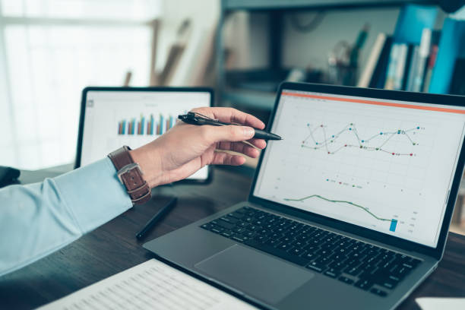

* **Energy Usage Monitoring Hardware: Some modern CPUs and motherboards may include built-in energy monitoring features, which can provide accurate data on power usage.**
* **Energy Usage Profiling: Profiling the energy usage of a CPU during specific tasks or workloads can provide insights into how different activities impact energy consumption.**
* **Power Usage Data Sheets: Manufacturers of CPUs often provide data sheets that specify the power characteristics of their processors, including information about typical power consumption under various conditions.**
* **Measuring CPU energy consumption is valuable for making informed decisions about hardware and software optimizations, as well as for reducing energy costs and environmental impact in various computing applications.**
* **Measuring CPU energy consumption accurately in Java can be quite challenging because it often requires access to hardware-level information that is not readily available through standard Java libraries. However, you can get an estimate of CPU energy consumption by tracking CPU usage and other system-level metrics. Here's an example of how you can measure CPU energy consumption using Java:**
* Java Program for CPU Energy measurement**:**

**public class CPUEnergyConsumptionEstimator {**

**public static void main(String[] args) {**

**// Constants**

**double samplingInterval = 1.0; // Sampling interval in seconds**

**double measurementDuration = 60.0; // Duration of measurement in seconds**

**// Initialize variables**

**double totalEnergyConsumed = 0.0;**

**// Main loop to estimate energy consumption**

**long startTime = System.currentTimeMillis();**

**long endTime = startTime + (long) (measurementDuration * 1000);**

**while (System.currentTimeMillis() < endTime) {**

**double power = readCPUPower();**

**double energy = power * samplingInterval;**

**totalEnergyConsumed += energy;**

**try {**

**Thread.sleep((long) (samplingInterval * 1000)); // Sleep in milliseconds**

**} catch (InterruptedException e) {**

**e.printStackTrace();**

**}**

**}**

**// Print the total estimated energy consumption**

**System.out.println("Total energy consumption: " + totalEnergyConsumed + " Joules");**

**}**

**// Function to read CPU power usage (in watts)**

**private static double readCPUPower() {**

**// Replace this with code to read actual power usage from your hardware or software**

**// You may need to use external libraries or tools to access this data**

**// For demonstration purposes, we'll simulate power usage here.**

**// Replace this with actual power measurement.**

**return 10.0; // Simulated power usage in watts**

**}**

**}**

* Code Explanation:

**CPU Energy Consumption Estimator, is designed to estimate the energy consumption of a CPU over a specified measurement duration.**

**It does so by periodically reading the power usage of the CPU and calculating the total energy consumed. Here's a step-by-step explanation of the program:**

* **Constants:**

**`sampling Interval`: This constant is set to 1.0, which represents the time interval in seconds between each power reading.**

**`measurement Duration`: This constant is set to 60.0, representing the total duration of the measurement in seconds.**

* **Variables:**

**`total Energy Consumed`: This variable is initialized to 0.0 and is used to keep track of the total energy consumed by the CPU.**

* **Main Loop :**

**- The program enters a loop that continues until the elapsed time (in milliseconds), calculated as the current time minus the start time, is less than the specified measurement duration.**

**- In each iteration of the loop:**

**- It calls the `read CPU Power()` function to obtain the current CPU power usage in watts. The actual implementation of this function will depend on how you obtain power usage data from your hardware or software. In the provided code, it simulates a constant power usage of 10.0 watts for demonstration purposes.**

**- It calculates the energy consumed during the current sampling interval by multiplying the power reading by the sampling interval duration.**

**- This energy value is added to the `total Energy Consumed`.**

**- The program then sleeps for a period equal to the sampling interval in milliseconds using `Thread.sleep()` to wait for the next reading.**

* **`read CPU Power()` Function:**

**- This function is a placeholder for reading the actual power usage of the CPU. In a real implementation, you would need to replace this function with code to read the real power usage data from your hardware or software. You might need to use external libraries or tools to access this data.**

* **After the loop completes, the program prints the total estimated energy consumption in joules.**
* Measure Electrical Energy Consumption:

**Measuring electrical energy consumption is important for understanding and managing your electricity usage. There are several methods and devices you can use to measure electrical energy consumption:**

* **Electricity Meter:This is the most common way to measure energy consumption in homes and businesses. It is typically installed by the utility company and provides a cumulative reading of your electricity consumption in kilowatt-hours (kWh). You can read the value on your electricity meter and track changes over time.**
* **Smart Meters:Many utility companies have replaced traditional electricity meters with smart meters. Smart meters provide real-time information about your electricity consumption and can be monitored remotely by both you and the utility company. This enables you to track usage more accurately and in near real-time.**
* **Plug-in Energy Monitor:These devices are designed for monitoring the energy consumption of specific appliances or devices. They are plugged into an electrical outlet, and you plug your device into the monitor. They can provide real-time data on energy usage and may offer features like cost estimation.**
* **Energy Monitoring Apps: Some smart plugs and devices come with associated mobile apps that allow you to monitor and control your appliances remotely. These apps often provide information on energy consumption and can help you identify which appliances are using the most energy.**
* **Energy Audits: Professional energy auditors can assess your home or business's energy consumption using specialized equipment and techniques. They can identify areas where you can reduce energy usage and save money.**
* **Submetering: In commercial and multi-unit residential buildings, submeters can be installed to measure the energy consumption of individual units or specific circuits. This helps allocate energy costs accurately among tenants or users.**
* **DIY Monitoring: You can also measure energy consumption manually by recording the readings on your electricity meter at regular intervals and calculating the difference. Keep a log of your readings to track your consumption over time.**

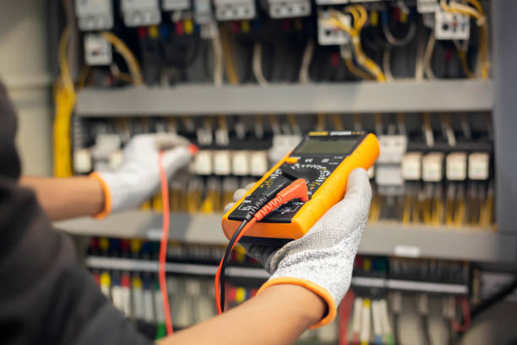

* **Power Usage Monitoring Software:There is power usage monitoring software available for some smart home automation systems. These programs can provide insights into energy consumption and offer suggestions for more efficient use of electricity.**
* **measure electrical energy consumption accurately, you'll want to choose the method that best suits your needs and the level of detail you require. Whether you're trying to reduce your electricity bills, identify energy hogs, or simply better understand your energy usage, monitoring your electrical consumption is a valuable tool.**
* Program for Electrical Energy Mearurement:

**import java.io.BufferedReader;**

**import java.io.InputStreamReader;**

**import java.net.HttpURLConnection;**

**import java.net.URL;**

**public class EnergyMeasurement {**

**public static void main(String[] args) {**

**// Replace with the actual URL or API endpoint of your energy meter**

**String meterDataUrl = "http://your-meter-api.com/get-energy-data";**

**try {**

**URL url = new URL(meterDataUrl);**

**HttpURLConnection connection = (HttpURLConnection) url.openConnection();**

**connection.setRequestMethod("GET");**

**int responseCode = connection.getResponseCode();**

**if (responseCode == 200) {**

**BufferedReader reader = new BufferedReader(new InputStreamReader(connection.getInputStream()));**

**String inputLine;**

**StringBuilder response = new StringBuilder();**

**while ((inputLine = reader.readLine()) != null) {**

**response.append(inputLine);**

**}**

**reader.close();**

**// Parse the response to extract energy consumption data**

**String meterData = response.toString();**

**double energyConsumption = parseMeterData(meterData);**

**System.out.println("Energy Consumption: " + energyConsumption + " kWh");**

**} else {**

**System.err.println("Failed to retrieve data from the meter. HTTP Response Code: " + responseCode);**

**}**

**} catch (Exception e) {**

**e.printStackTrace();**

**}**

**}**

**private static double parseMeterData(String meterData) {**

**// Implement parsing logic specific to your meter's data format**

**// This may involve JSON, XML, or other data formats**

**// For simplicity, we assume a JSON format here**

**// Modify this part based on your meter's data structure**

**try {**

**// Parse JSON or extract relevant data**

**// Example: JSONObject jsonObject = new JSONObject(meterData);**

**// double energyConsumption = jsonObject.getDouble("consumption");**

**// For this example, we'll simulate a random energy consumption value**

**return Math.random() * 100.0;**

**} catch (Exception e) {**

**e.printStackTrace();**

**return -1.0;**

**}**

**}**

**}**

* Program Explanation :
* **The provided Java program, EnergyMeasurement, is a simplified example of how you might use Java to measure electrical energy consumption by retrieving data from a hypothetical energy meter through an HTTP API. Let's break down the program step by step:**
* **The program begins by importing the necessary Java libraries to handle HTTP requests and data processing.**
* **You are instructed to replace the meterDataUrl variable with the actual URL or API endpoint of your energy meter. This URL is where the program will make an HTTP GET request to retrieve energy consumption data.**
* **The program uses the java.net.URL and java.net.HttpURLConnection classes to create an HTTP connection to the specified URL.**
* **It sends an HTTP GET request to the meter's API by calling connection.setRequestMethod("GET").**
* **The program checks the HTTP response code to ensure that the request was successful. A response code of 200 indicates a successful response, while other codes might indicate errors or issues.**
* **If the response code is 200, the program proceeds to read the response from the meter's API.**

**It sets up a BufferedReader to read the response line by line, and it appends each line to a StringBuilder to build the complete response.**

* **The program calls the parseMeterData method, passing the complete response as a string to this method for parsing.**
* **The parseMeterData method is where you would implement the logic to extract energy consumption data from the meter's response. In this example, it is assumed that the data is in a JSON format (which is common for APIs), but you should modify this part based on your meter's data structure.**
* **If the response is in JSON format, you might use a JSON parsing library, like org.json.JSONObject, to extract the relevant data. However, in this example, it simply generates a random energy consumption value as a placeholder.**